**Parking Lot System**

**1. Floor**

* floor_id (PK)
* floor_number (e.g., 1, 2, B1)

**2. Slot**

* slot_id (PK)
* floor_id (FK → Floor)
* vehicle_type_id (FK → VehicleType)
* is_occupied (boolean)

**3. VehicleType**

* vehicle_type_id (PK)
* name (Car, Bike, Truck, EV, etc.)

**4. Pricing**

* pricing_id (PK)
* vehicle_type_id (FK → VehicleType)
* price_per_minute
* price_per_hour

**5. Ticket (Entry/Exit transaction)**

* ticket_id (PK)
* slot_id (FK → Slot)
* vehicle_type_id (FK → VehicleType)
* vehicle_number (license plate)
* entry_time
* exit_time (nullable until exit)
* total_price (calculated at exit)
* status (Active, Closed, Cancelled)

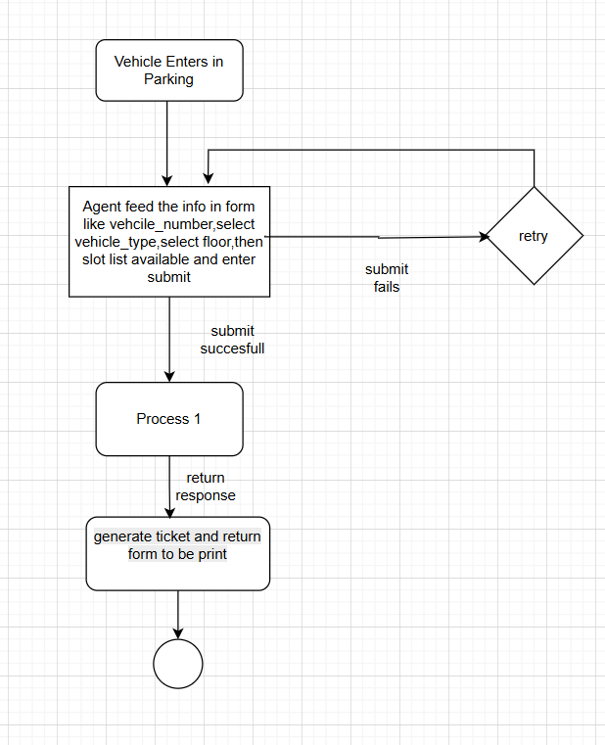

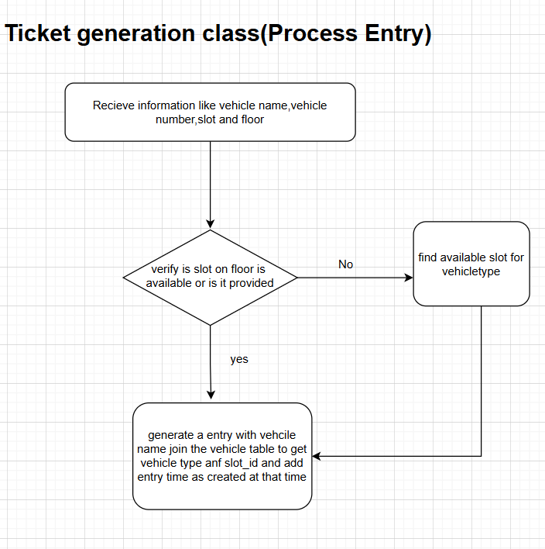

**Flow of GenerateToken Class**

1. Input Received
   1. vehicle_number (e.g., DL10AB1234)
   2. vehicle_type (Car, Bike, etc.)
   3. (Optional) slot_number, floor_number
2. Validate Slot & Floor
   1. If slot_number and floor_number are provided from UI: ✅ Use them directly.
   2. If null → call Slot service/class to:
      1. Find an available slot on a floor where:
         1. slot.vehicle_type_id == vehicle_type_id
         2. slot.is_occupied == false
3. Resolve VehicleType ID
   1. Query VehicleType table by name (Car, Bike, etc.) → get vehicle_type_id.(Vehicle class)
4. Create Ticket Entry (Ticket class)
   1. Generate ticket_id (GUID/UUID).
   2. Insert a record into Ticket table:
      1. ticket_id → random GUID
      2. slot_id → from UI or selected by Slot class
      3. vehicle_type_id → from VehicleType
      4. vehicle_number → input value
      5. entry_time → DateTime.Now
      6. exit_time → NULL (until exit happens)
      7. total_price → 0 initially
      8. status → Active
5. Update Slot Occupancy
   1. Update the chosen slot.is_occupied = true.(Slot class)
6. On Exit
   1. When vehicle exits, fetch ticket by ticket_id. (Ticket class)
   2. Calculate duration = exit_time - entry_time.(Pricing class)
   3. Fetch pricing from Pricing table using vehicle_type_id.
   4. Compute total_price.
   5. Update ticket.exit_time, ticket.total_price, and ticket.status = Closed.(Generate token class)
   6. Free the slot → slot.is_occupied = false.(slot class)